Prioritize

Joel Wilhelm, Cody Jones, Wajahat Iqbal, Shahrukh Rehman

# Project Goal

Reminder System that incorporates a priority value with time.

# Project Description

Prioritize is an application that aims to organize the user’s life by letting them type in a reminder for something that needs to be done by a certain time, and reminding them in intervals based on priority and the time between creation and the “due-date.” This lets the user periodically be reminded of the event or task over time rather than the user deciding having to decide for themselves. Once reminded, the user can choose to have the reminder be stopped, snoozed to remind the user in an hour or so, or simply be reminded at a later time that is again based on the priority value and the time between the current date and the “due-date.” These reminders will be synced across the user’s android devices allowing them to be reminded at any convenience to them.

# Requirement Specifications

## Functional Requirements:

The user must be able to create a new reminder. When creating a reminder, the user must be able pick a date and have the option of picking a time with that date. The user must also be allowed to pick multiple dates. The user must be able to view the current list of reminders that have been created and have the option of deleting them and editing them. The option of picking a alert versus an alarm must be available, that is a simple notification versus an alarm that won’t go off until user interaction. A reminder must have the option of being repeated. When a reminder is being alerted the notification itself must have the option of “Snooze” which tells the app to remind the user again sooner than later, “Remind me Later” which sets another reminder based on percentage of time remaining via the priority algorithm, and “Stop Reminding Me,” this will cancel the reminder entirely and leave it on the reminder list until the date/time has passed.

## User Interface Requirements:

The UI must implement a minimalistic design. The home page must display a list of the current reminders along with a floating action button at the bottom right for adding a reminder. Swiping to the right must reveal a calendar that has a mark on the dates that have each reminder due date, along with a mark for when that reminder is being alerted. The two of these marks must be displayed in a different style for differentiation.

## Usability Requirements:

The user must be able to create a reminder in a substantially small amount of time. These reminders must be synced automatically with the rest of the users android devices that have the application installed on them under the same Google Account.

## Performance Requirements:

The application must have a minimal response time in order for creating a reminder swiftly, and uninterruptedly. That means punctual app transitions, 0.1 seconds, opting for quick GUI animations rather than slower ones. Syncing across android devices must be as quick as the Google Drive API allows.

## Security Requirements:

The users reminders must not be available for viewing by anyone other than the user and then only through the application itself. The Google Drive API used to syncing android devices uses Google’s account system for security in the cloud.

# System

When user creates a reminder a description is set by the user, a date (or dates) is set by the user, a time is optionally set by the user, a priority value is set via a slider, and the user has options for ignoring the priority system, setting it to be repeatable, and changing from the default alert style to an alarm style notification. Once the reminder is submitted, the priority algorithm takes the priority value, the current date and time, and the date (or date and time) of the reminder and calculates a date and time for the user to be reminded based on the percentage of time between the two dates. The information the user entered and the new priority date is saved in a local device database and is synced with the user’s Google Cloud via the Google Drive API. This allows for the user’s other android devices that have the application installed under the same account to sync with the Cloud and set the reminder on that system as well. The alerts are set via the Android system which lets the application be closed until the time of activation of the event.

# Subsytems

* Home Activity: Fragment system for activity to display the current list of reminders on one slide, while swiping right reveals a calendar with reminders marked on dates.
* Notifications:Reminds the user of the task depending on the priority set by the user through sending a notification via an alert or an alarm. Notifications will offer Snooze, Remind Me Later, and Stop Reminding Me.
* Reminder Database: Manages the user’s reminders, this database is synced with the cloud so that the user’s other android devices can share all of the same information.
* Priority Algorithm: Set’s the date and time for the user to be alerted about a task they have created a reminder for. Takes the time between the date of creation and the “due-date” to set a new date based on the percentage of time between the two.
* GUI: Provides the user with menu, buttons, and calendar for priority, date and time input.
* Adding a Reminder: System for the user to create a reminder to be added to the reminder database. Has field for reminder description, date picker, time picker, repeatable check, alert/alarm switch, and the option for ignoring priority system.

# 

# 

# 

# Timeline

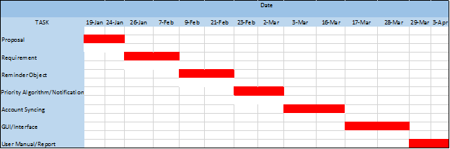

Risk Factors (new)

There are many risk factors involved in any project undertaking. So, it is therefore natural that there are risk factors within Prioritize as well. Listed here are potential risks factors that may have an impact on the success and implementation of Prioritize.

* Time – Time is always a factor in any project, big or small. If not enough time is available, the project may become rushed, and will suffer thusly. There is limited time in which to plan, prepare, and implement Prioritize. Thusly, time is a risk factor.
* Experience – None of the team has used Android Studios before, or programmed an application designed for a mobile device. This lack of experience is a risk factor, because time investment is mandatory to learn about the environment, and to understand what is necessary to begin implementation.
* Groupwork – The fact is that Groupwork can be difficult. Lack of communication is a major factor in failed projects, so being able to communicate is vital. The fact that group members have other classes, jobs, and outside work other than Prioritize means that getting together to work on this project is a Risk Factor.
* Waterfall Method – The waterfall approach for software engineering is not a very successful method for designing and implementing a piece of software. While it can be useful in some ways, it is possible to get caught up in the overhead, and not spend enough time working on the project. It is a trade-off between planning, preparation, and documentation, and getting code written. This is a Risk Factor.

Data Dictionary (new)

1. **Alarm** - More intrusive than a simple alert. Has a noise that will not stop until acknowledged by user.
2. **Alert** - A simple message sent to the user’s device. Unobtrusive and simple.
3. **Creation Date** - Day on which the reminder for an event was created. Will be a text based format. DD/MM/YYYY
4. **Creation Time** - Time at which the reminder for an event was created. Will be represented internally as military time, and will have an option to be shown as standard time.
5. **Database** - A structured set of data that can be searched and questioned by queries. Will be used to store the Reminder objects, and will use the SQLite language.
6. **Due Date** - Day on which the event will be due. Will be a text-based format. DD/MM/YYYY.
7. **Due Time** - Time at which the event will be due. Will be represented internally as military time, and will have an option to be shown as standard time.
8. **Event** - The reason for creating a reminder in the first place. A thing that needs a due date and a reminder of said due date.
9. **Event Description** - A String that describes the Event in question.
10. **Google Drive** - An API that assists with security, synchronization, data storage, user accounts, and having the ability to link multiple devices to one account. Has a one-time $25 usage fee.
11. **Java** - A programming language used for android devices.
12. **JSON** - A data interchange language, meant for easy data transfer between languages, systems, etc.
13. **Notification** - How the user actually gets reminded/notified of an upcoming event.
14. **Notification Type** - What kind of notification is it? Can be an Alarm or an Alert.
15. **Prioritize** - Name of this application.
16. **Priority** - Priority is defined as how important a particular task is. This will have an impact on when the user will be reminded of an event, based on the Priority Algorithm.
17. **Reminder** - An object that encompasses: Due date, Creation Date, Due Time, Creation Time. Event Description, Notification, and Notification Type. Will be used as the object that is used to save and store information. The system depends on Reminder objects as an integral part of Prioritize.
18. **SQLite** - A database language.
19. **XML** - A programming language used for storing and transporting data.

Algorithm Analysis (new)

Priority Algorithm

Database Lookup

Sync to Google Drive

Converting Text to JSON / JSON to Text

Creation of Reminder Object

/** Any others we want to add **/

Dataflow (new)

Reminder Deletion

When a reminder is deleted from a device, the reminder will be removed from that device’s database, and when synched with Google Drive, will put a note for deletion in the other device folders, so they will know to delete that reminder from their respective devices when synched. It will also remove the reminder from the reminder folder in Google Drive as well. This is shown in Fig. 1.

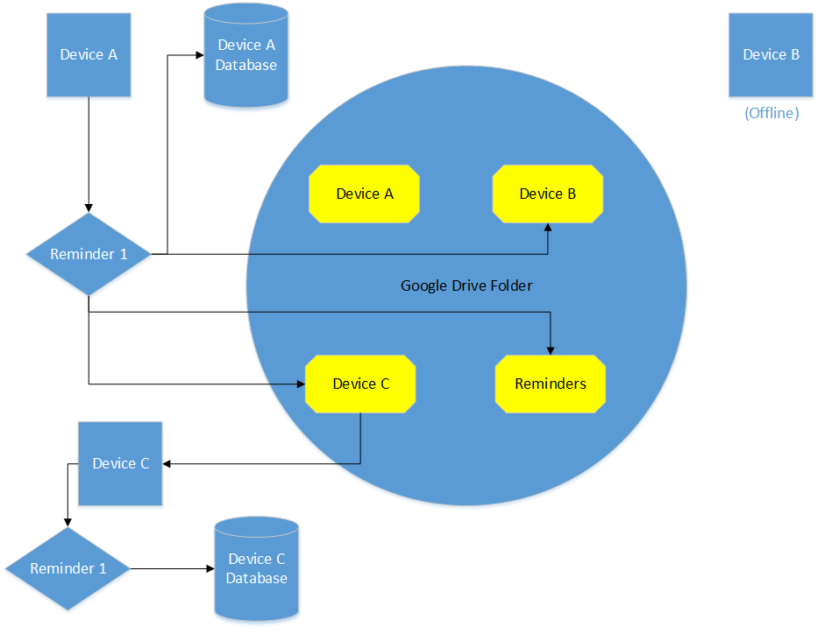  
Fig. 1 – Reminder Deletion Dataflow

Creation of a Reminder

When a Reminder is created, it will be stored into the local SQLite Database. When synched to Google Drive, it will also be stored there as well. The reminder will be visible from the Home Page, as well as from the Calendar page.

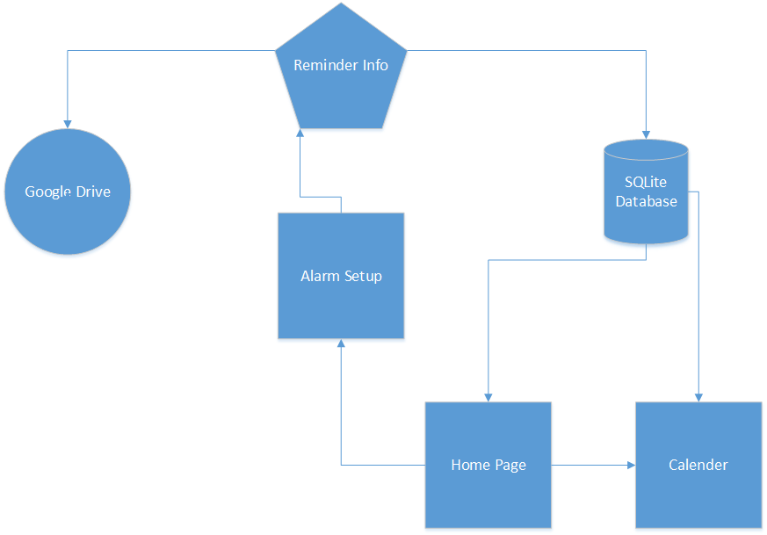

Fig. 2 – Reminder Creation Dataflow

Citations (new)